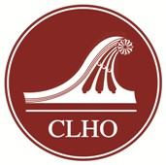
2021 CLHO Awards of Merit
Nomination Coversheet

Upload application materials to the 2021 Awards of Merit Dropbox at https://www.dropbox.com/request/eZ2atWbTyTRKn6eh8cmO. Applications must be received by January 13, 2020. For questions, contact Amrys Williams, CLHO executive director, at director@clho.org.

NOMINEE INFORMATION

Title of Project (if applicable):

Nominated for (check only ONE category): ☐ Project ☐ Individual Achievement

Nominee/Nominated Organization:

Nominee Mailing Address:

Phone: Email:

CONTACT INFORMATION

List the person who should be our main point of contact for this nomination. If someone other than the nominee is making the nomination, please include their information here.

Name:

Organization:

Mailing address:

Phone: Email:

Did your project receive funding from Connecticut Humanities? Yes ☐ No ☐

