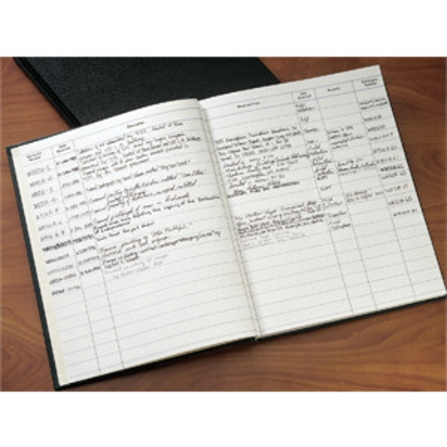

ROLLOVER TO ZOOM
PreviousNext

Accession Book
Part #: 50003
$59.50

Quantity:
ADD TO CART
ADD TO WISHLIST

